# JUnit-Basic testing exercises solution

**Exercise 1: Setting up JUnit**

### Steps:

* Create a new **Java Project** in Eclipse.
* Right-click on the project → **Build Path** → **Add Libraries** → **JUnit** → Choose **JUnit 4** → Finish.

This adds junit-4.x.x.jar to your classpath.

**Exercise 2: Writing basic Junit tests**

**Example class:(Calculator.java)**

public class Calculator {

public int add(int a, int b) {

return a + b;

}

public boolean isPositive(int number) {

return number > 0;

}

}

**Its test class:(CalculatorTest.java)**

import static org.junit.Assert.*;

import org.junit.Test;

public class CalculatorTest {

@Test

public void testAdd() {

Calculator calc = new Calculator();

assertEquals(7, calc.add(3, 4)); // Output: Pass

}

@Test

public void testIsPositive() {

Calculator calc = new Calculator();

assertTrue(calc.isPositive(5));

assertFalse(calc.isPositive(-3));

}}

**Output:**

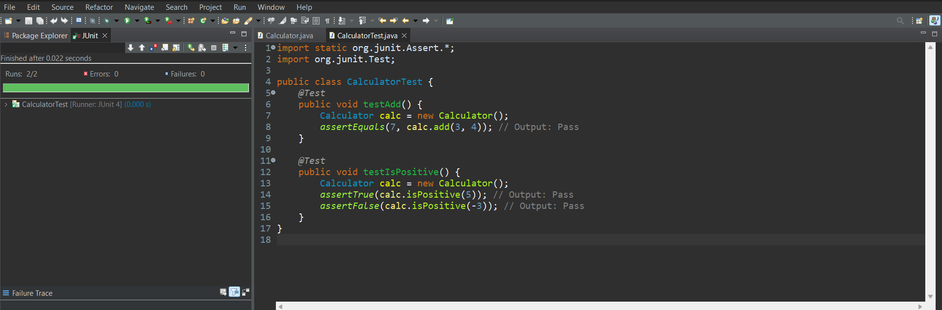

**Exercise 3: Assertions in JUnit**

**AssertionsTest.java:**

import static org.junit.Assert.*;

import org.junit.Test;

public class AssertionsTest {

@Test

public void testAssertions() {

assertEquals(5, 2 + 3);

assertTrue(5 > 3);

assertFalse(5 < 3);

assertNull(null);

assertNotNull(new Object());

}}

**Output:**

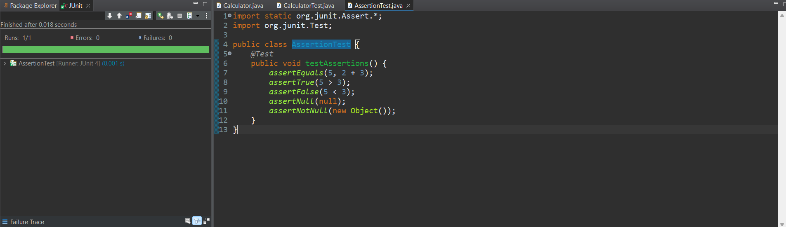

**Note:** We are only asserting whether the condition is suffice. We can check the output by checking if there occurs error under the JUnit tab.

**Exercise 4: AAA Pattern with Setup/Teardown**

**User.java:**

public class User {

private String name;

public void setName(String name) {

this.name = name;

}

public String getName() {

return name;

}

}

**UserTest.java:**

import static org.junit.Assert.*;

import org.junit.Before;

import org.junit.After;

import org.junit.Test;

public class UserTest {

private User user;

@Before

public void setUp() {

// Arrange

user = new User();

}

@After

public void tearDown() {

user = null;

}

@Test

public void testSetName() {

// Act

user.setName("Alice");

// Assert

assertEquals("Alice", user.getName()); // Output: Pass

}

}

**Output:**